**Process of Importing Data in Matlab**

**Grant Livingston**

**3/2/15**

Used because I don’t trust the import function that Matlab has; it has given me some weird results.

**1. Concatenate all the text files that you want to import into Matlab.**

Create a new folder called Data Copy, and copy the section of remote data of interest into that new folder. I usually only do about 1 month at a time.

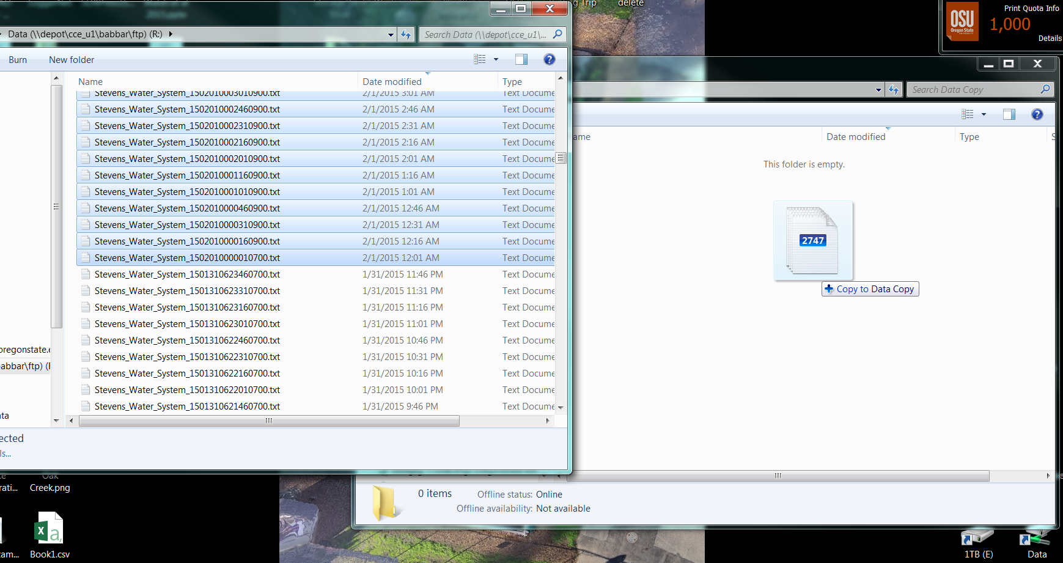

Shift+right click on a blank space in your new folder, Data Copy, and Open Command Window Here

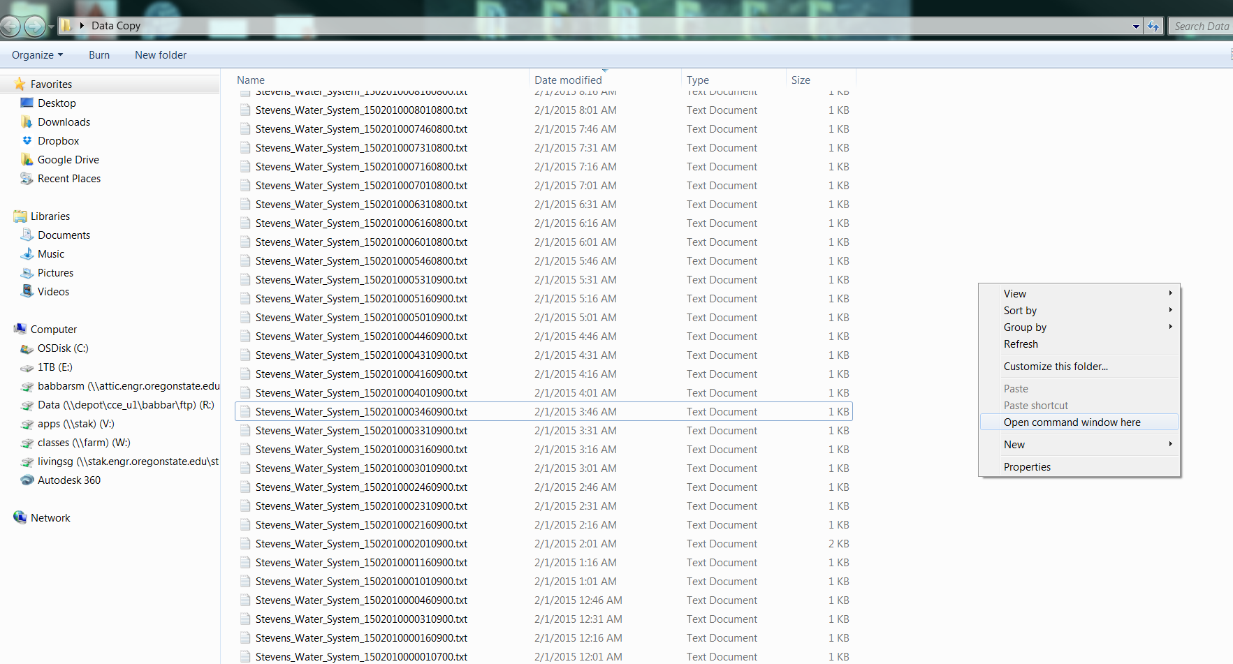

Type

for %f in (*.txt) do type "%f" >> output.txt

and press enter to concatenate all the files. This process can take a few minutes, depending on the number of files that you are concatenating.

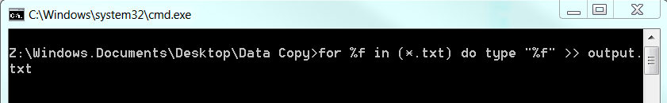

This will make a file called output.txt in your Data Copy folder. You can delete all the other files in the Data Copy folder at this point, because you won’t need them. N**ever delete any files from the folder that has all of the incoming files from the data logger.**

**2. Import output.txt into Excel**

Use the “From Text” import tool in the Data tab.

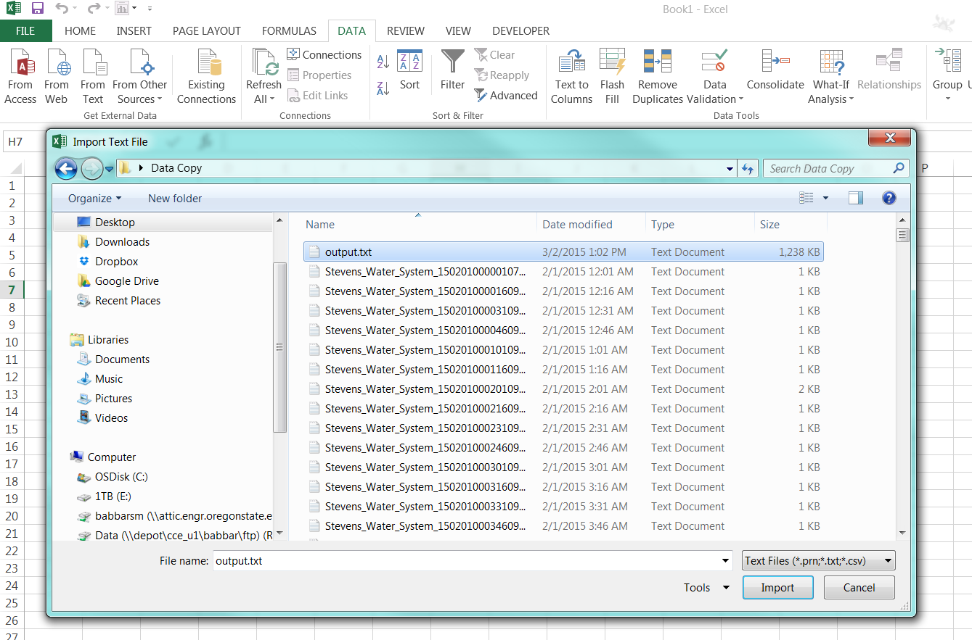

Make sure “Delimited is marked” staring at row 1, with file origin in the United Stated.

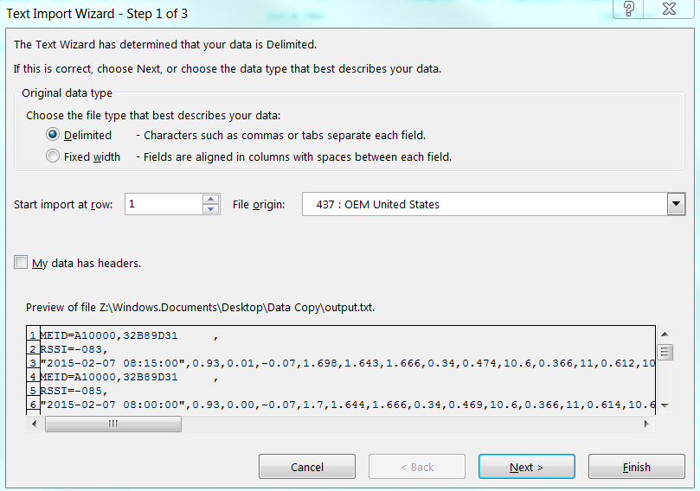

Just select comma delimited.

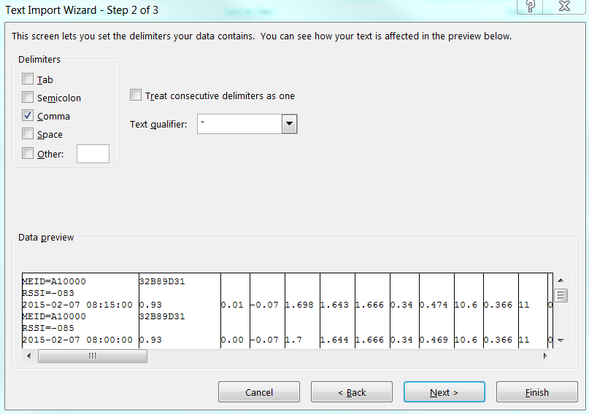

On the last screen, select Date YDM for the first column.

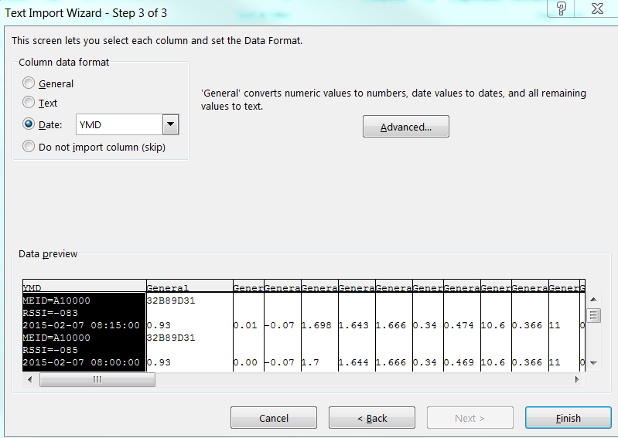

Click okay and import it to A1 in your worksheet.

**3. Filter the data.**

Create 2 empty columns to the left of A.

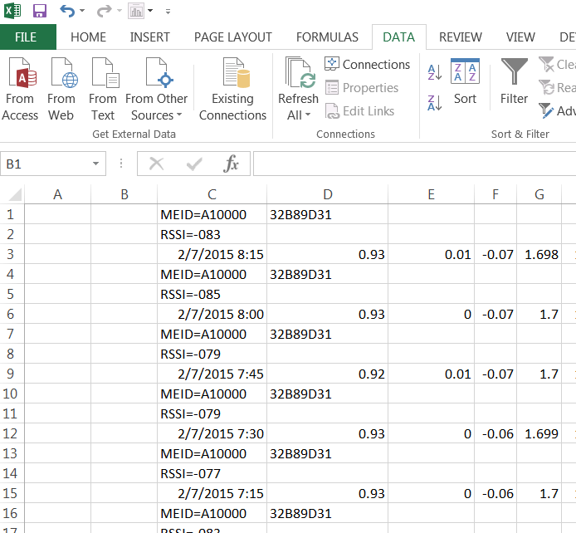

Number the rows from 1 to the end in the B column. If you type in the first three rows, you should be able select those three rows, then double click the bottom right corner to fill in the rest.

Then type

=mod(B1,3)

into the cell A1. Copy this formula to the rest of the rows in column A. The result should look like this.

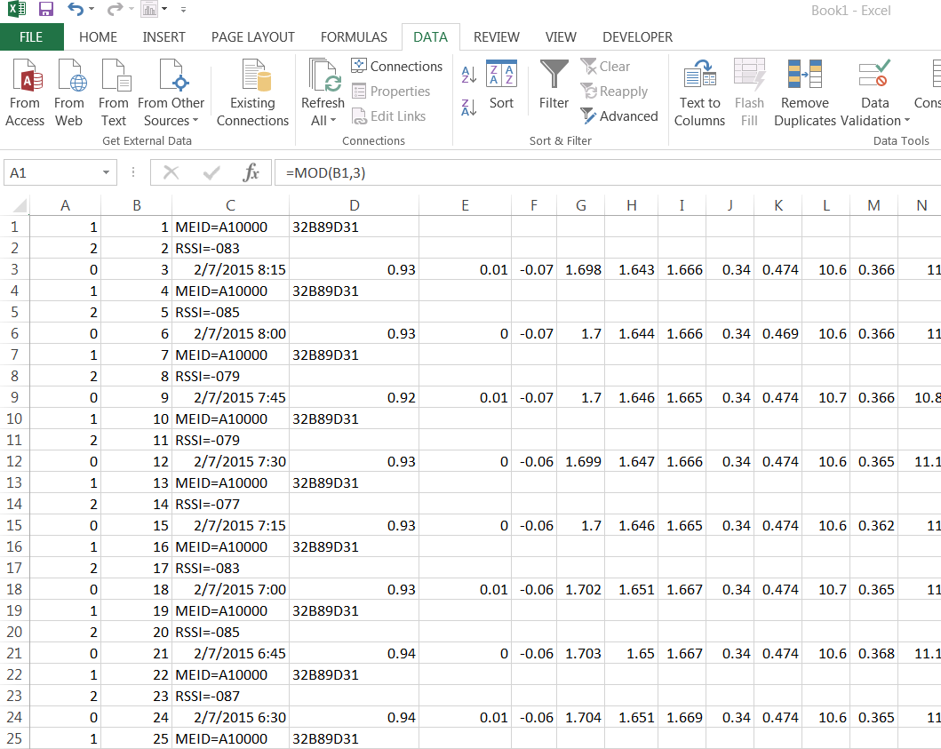

Highlight the first column, then in the Data tab, click Filter, click on the little arrow that appears at the top of column A, and a menu will show up below it. Uncheck the 0, or whatever row has the data you want to keep in it. We want to delete the MEID and RSSI rows.

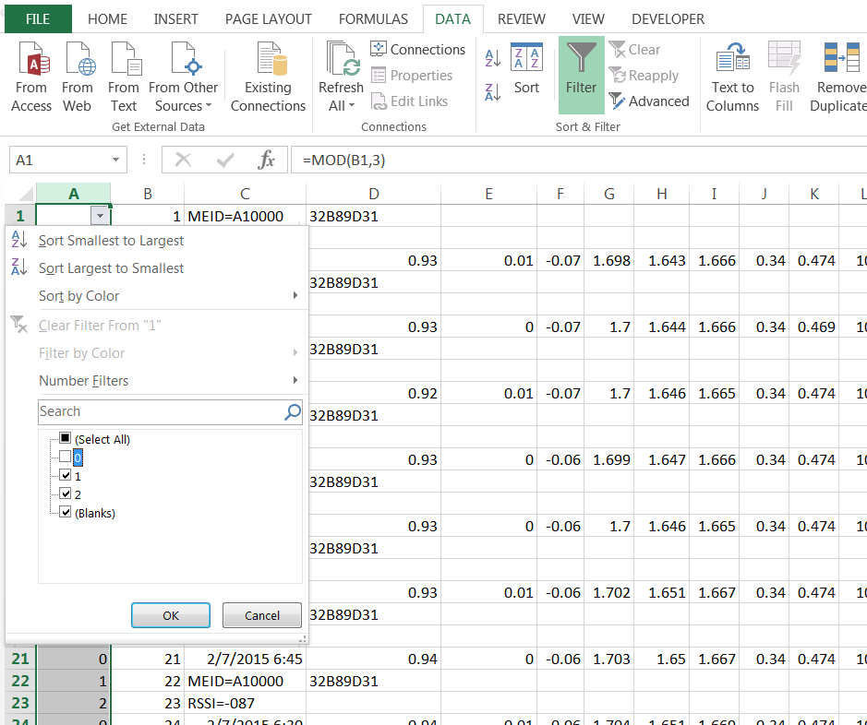

At this point, I always seem to get a situation where the first few rows that I want to keep are hidden (up to row 71 in my example), and the rest are not hidden. Highlight the first bunch of rows that just show the MEID and the RSSI, and delete them.

It should then look like this after you delete the first bunch of rows you don’t want:

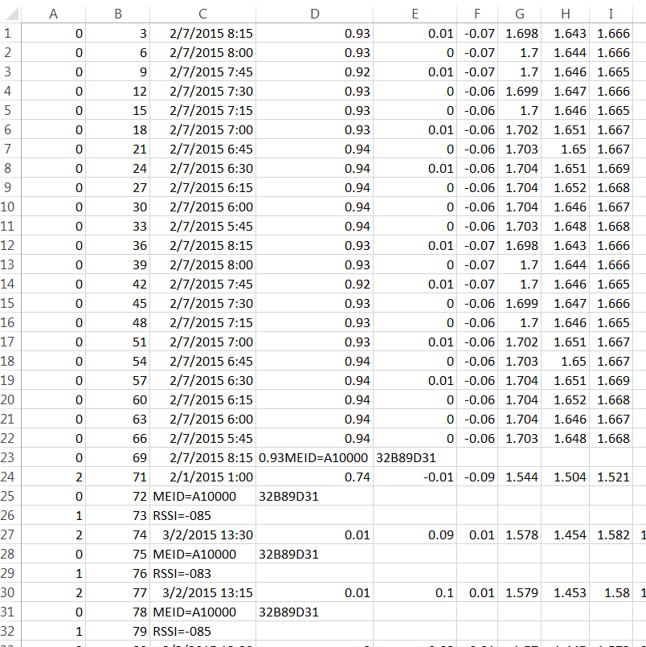

We will then have to filter a few more times.

Use the filter button again. This time I needed to deselect 2 from the filter drop down menu to hide the rows with the data. It now looks like this

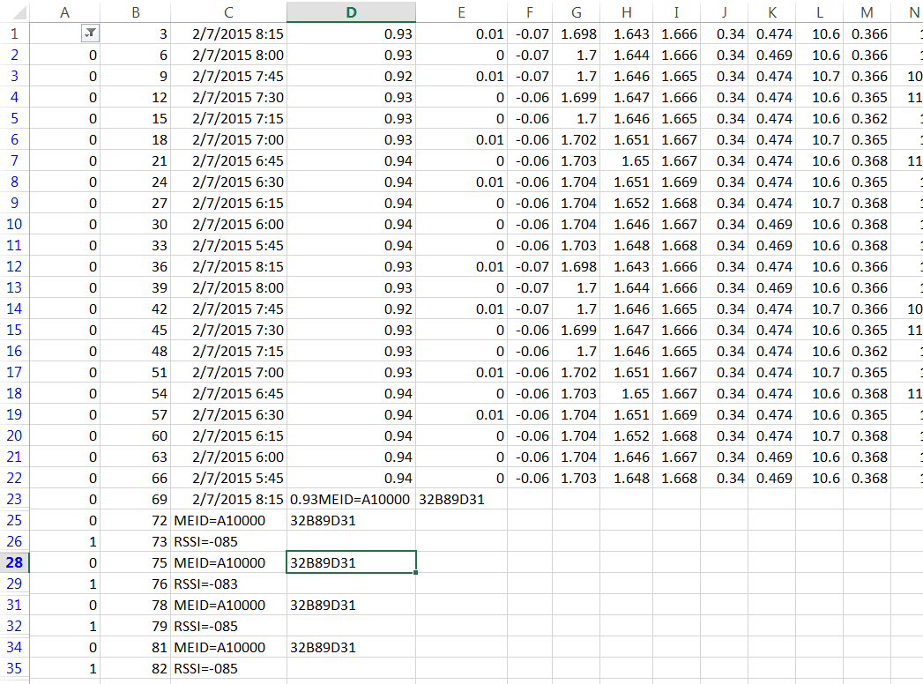

Scroll down to see if there are any other rows with data you want to keep that are showing. If not, delete all rows with MEID and RSSI. Otherwise, repeat above steps.

When finished with this first filtering step, your screen should look like this:

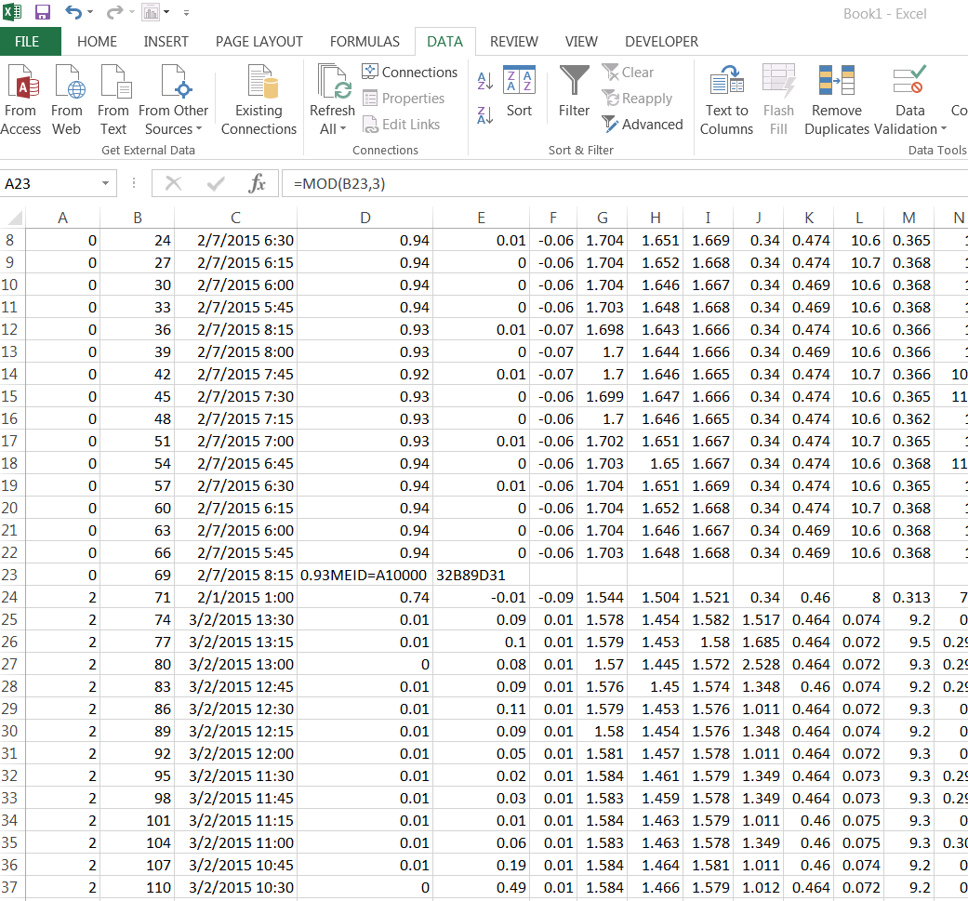

At this point, notice that row 69 in my example has some weird stuff in it. We will arrange all of the dates from oldest to newest to double check that there are no repeats, as you can see that there is a repeat of this one.

**5. Quality Control**

Use the  tool in the data tab to arrange all of the dates from oldest to newest.

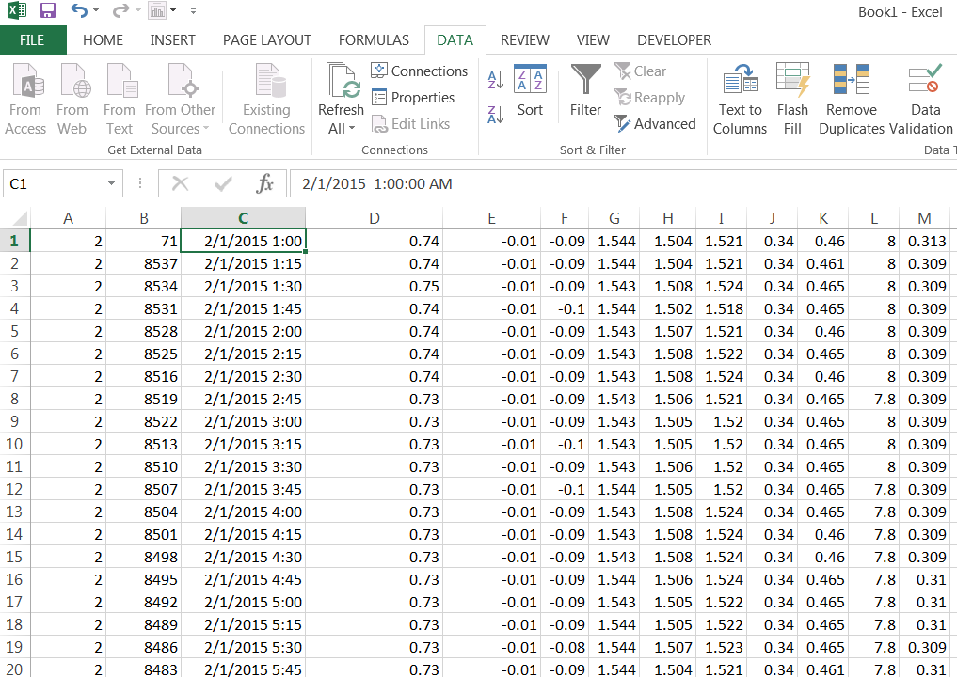

Delete the first column, and delete the numbers in the second column. Write this code into A2 and copy to all rows to check for repeat dates:

=IF(B2=B1,1,0)

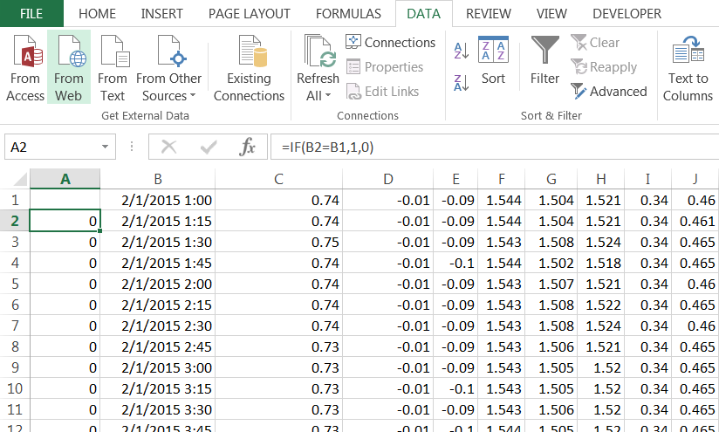

Now scroll down and delete any rows that have repeat time and dates (shown with a #1). Make a cell at the bottom of the A column that sums all the numbers in the A column. It should be equal to 0 after you have deleted all the repeats.

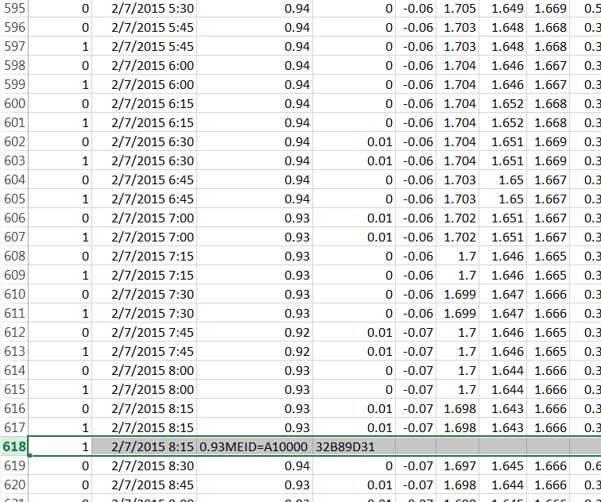

Delete the A column with all of the zeros and ones. Insert a new column to the right of the dates that starts at 1 and increases by 1 for each row. This is used if you are modifying one of the lgr.txt files to keep track of the record you are adding to it. Put the date in column A into the same format as the lgr.txt. It will be a custom format: YYYY/MM/DD HH:MM:SS

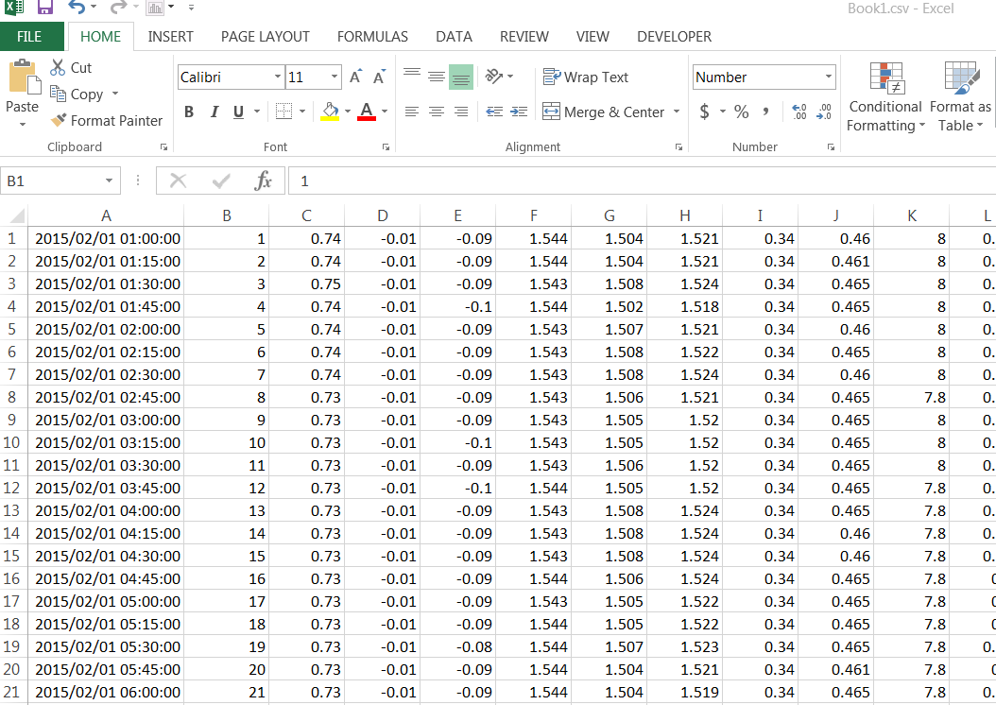

Now save the file as a .csv (comma delimited). It should now be easy to import using Matlab. You can add a heading row in the .csv files so that all the variables automatically have names.